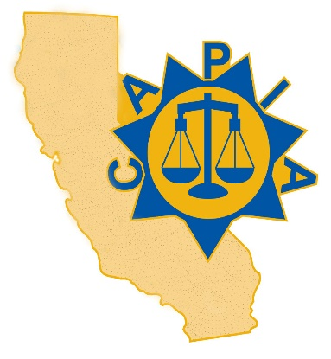

**California Association of**

**Probation Institutions Administration**

**64th Annual Conference:**

**Celebrating Change and Excellence**

**November 5-7, 2024**

**Monday, November 4th**

* 4-5pm: Registration

**Tuesday, November 5th**

* 7-8am: Registration
* 8-8:30am: Welcome
* 8:30-9:30am: Regional Meetings
* 9:30am-12:00pm: Brett Peterson, Director of Utah Diversion of Juvenile Services, Transformative Leadership.
* 12:00-1pm: Lunch
* 1-5pm: Penny Sampson, CJJA Associate Member, Staff Wellness and Retention.
* *Optional: 5:45-7pm Reception*

**Wednesday, November 6th**

* 8-8:10am: Orijin Presentation
* 8:10-10am: Quawntay Bosco Adams, President of Chasin Freedum Foundation, Resiliency and Greatness.
* 10am-12pm: SYTF Youth Panel
* 12-12:45pm: Lunch
* 12:45-1:45pm: Awards Banquet
* 1:45pm: Conference Photo (wear department shirt)
* 2pm-5pm: Chief’s Panel

**Thursday, November 7th**

* 8-12pm: Charles Celano, Retired Police Chief (Tustin), Coaching and Mentoring.