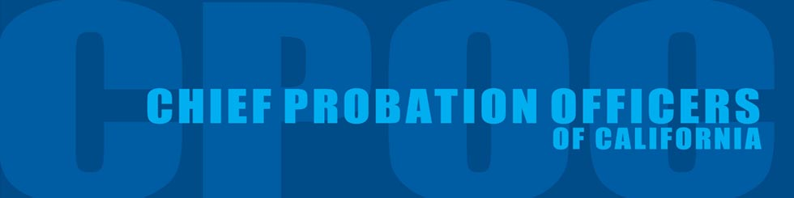

For Immediate Release Contact: Laura Dixon
Friday, September 30, 2016 Mobile: 510-384-3020

CPOC Announces Final Results of 2015-2016 Legislative Package

SACRAMENTO – Today, the Chief Probation Officers of California (CPOC) released the following announcement outlining their successful legislative package for 2015-2016, all signed into law by Governor Brown. Among the highlights are bills that will codify best practices for room confinement in juvenile detention facilities and a pilot program in five counties that will allow 18-21 year olds to serve their sentence in juvenile halls rather than county jails.

“This has been a very productive and successful legislative year for probation,” said Chief John Keene, CPOC Legislative Committee Chair. "You can easily see weaved as a theme through all our legislation is a commitment to the core values that probation departments throughout California hold as the gold standard of our work - Public safety through accountability and evidence-based rehabilitation programs that transform lives and keep our communities safe. The work we have done this year has created the foundation for ongoing relationships that we can build upon and continue to craft policy for the betterment of the people we serve. Thank you to all our legislative sponsors, the Legislature, Governor Brown and the countless coalition partners we worked with to craft and pass all this important Legislation.”

Below is a list of CPOC priority bills:

- SB 1143 (Leno) – Co-sponsor
Juveniles: room confinement: Designed to balance the goals of improving youth outcomes and maintaining the safety of youth and staff, SB 1143 would provide limitations and guidance on when and how room confinement can be used. It will be limited to no more than four hours in most cases, with the goal of returning the youth back to programming as soon as possible. The bill also calls for documentation of practices and imposes a complete ban on its use for the purposes of punishment, coercion, convenience or retaliation.
- SB 1004 (Hill) – Support
Young Adults: deferred entry of judgement pilot program: Authorizes Alameda, Butte, Napa, Nevada, and Santa Clara counties to adopt a pilot program that makes young adults ages 18 to 21 who commit non-violent felonies eligible to serve their sentence in juvenile hall, rather than in adult county jail, if determined suitable by the probation department, in consultation with the superior court and other local criminal justice stakeholders
- SB 266 (Block) – Sponsor
Probation and Mandatory Supervision: flash incarceration: Allows probation departments to use “flash incarceration” to hold offenders accountable with less disruption to work, home, or treatment programs.
- AB 2165 (Bonta) – Support
Firearms: prohibitions: exemptions: Restores the ability of probation, as peace officers under the law, to be able to purchase non-roster firearms for on-duty purposes.
- AB 1998 (Campos) – Support
Juveniles: data collection: Revises and streamlines reporting measures on juvenile justice funding programs.
- SB 1121 (Leno) – Support
Privacy: electronic communications: Would authorize a government entity, without a warrant or other order, to access electronic device information by means of physical interaction or electronic communication with the device

CPOC is an organization that provides leadership in the mobilization, coordination, implementation and funding of probation programs and services throughout California. CPOC’s goal is to provide public safety through detention, treatment, victim services, crime prevention, and delinquency prevention. In addition, CPOC ensures and provides quality investigations and supervision of offenders for the Courts. The organization is comprised of 59 appointed Chief Probation Officers throughout the state.

###

